Week 3 Lab Task
Scanning & Enumeration
NIAI NAVTTC — Certified Ethical Hacker (CEH) Course
⚠ Important: All tasks must be performed only in your isolated virtual lab environment. Never test on real networks or systems without explicit written permission.

Task: Conduct a comprehensive network scan to identify all active hosts and services. Perform vulnerability scanning on identified hosts. Perform active enumeration on a Windows-based network to identify Active Directory users, groups, and systems.

Step 1 — Set Up Your Target VM
▶ Download and Import Metasploitable 2
Go to: sourceforge.net/projects/metasploitable/
Download the Metasploitable 2 zip file and extract it.
In VirtualBox: File → Import Appliance, or just add the .vmdk as a new VM.
Set BOTH Kali and Metasploitable to the same 'Host-Only Adapter' network so they can talk to each other.
Start Metasploitable. Login: msfadmin / msfadmin
Run ifconfig to find its IP address (e.g. 192.168.56.101). Note this IP — you will use it in all commands below.
Scanme.nmap
Step 2 — Network Scanning with Nmap
▶ Ping Sweep — Find Live Hosts
nmap -sn 192.168.56.0/24
This lists all devices that are online on your host-only network.
▶ Full Port Scan with Service Detection
nmap -sV -p- 192.168.56.101
-sV detects service versions. -p- scans all 65535 ports.
▶ OS Detection
nmap -O 192.168.56.101
▶ Vulnerability Scan with Nmap Scripts
nmap --script vuln 192.168.56.101
This runs Nmap's built-in vulnerability detection scripts against the target. 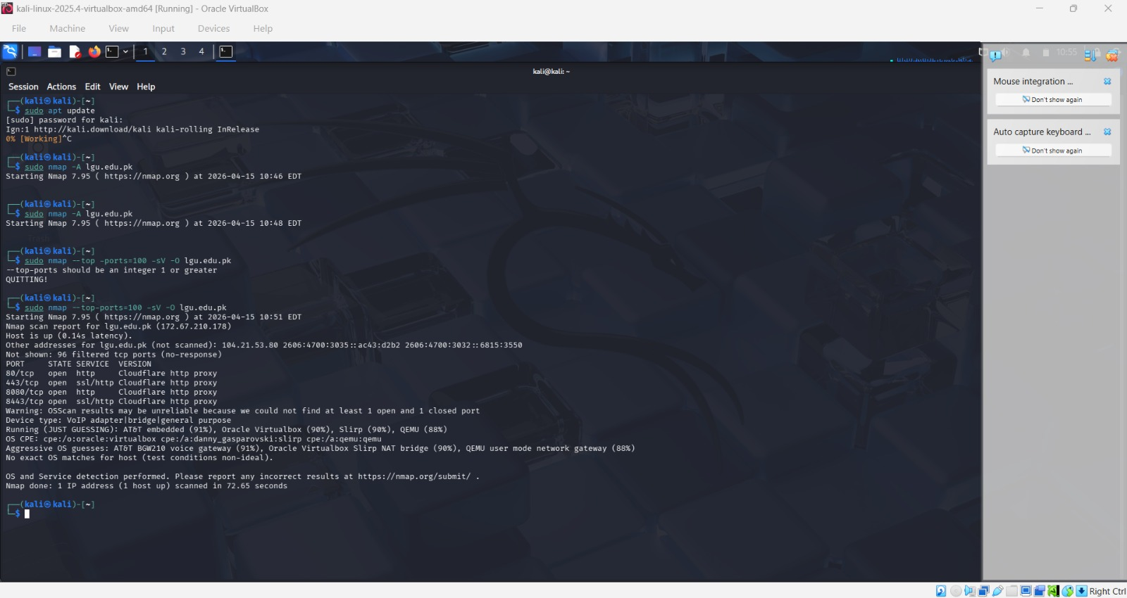
Step 3 — Enumeration
▶ Enumerate Windows / Active Directory (if Windows VM is available)
enum4linux -a 192.168.56.101
This tool extracts users, groups, shares, and policies from Windows/Samba targets.
▶ SMB Enumeration
nmap --script smb-enum-users 192.168.56.101
nmap --script smb-enum-shares 192.168.56.101
▶ Additional Enumeration with Nmap Scripts
nmap --script=nbstat 192.168.56.101 # NetBIOS info
nmap --script=snmp-info 192.168.56.101 # SNMP info
nmap --script=dns-brute 192.168.56.101 # DNS brute force
Step 4 — Document Your Findings
▶ Write a Scan Report
Record the following for each host identified:

IP address and hostname
127.67.210.178 and LGU.edu.pk

Open ports and running services
80: HTTPS
445: SSL
8080: HTTP

Detected operating system
Hidden due to Cloudflare

Vulnerabilities identified by Nmap
Although these ports are commonly used for web applications, the presence of ports like 8080 and 8443 can sometimes suggest alternative management interfaces or development environments. However, since they are recognized as Cloudflare HTTP proxy services, they are most likely part of Cloudflare’s standard edge network infrastructure.

2. Service Fingerprinting
In this scan of lgu.edu.pk, the service fingerprinting result is effectively a false positive regarding the backend server. Because the target is protected by Cloudflare, Nmap’s -sV (service version) probes were responded to by a Web Application Firewall (WAF) rather than the actual university server.

Users or shares discovered during enumeration
The scan performed was a service and version scan, which identifies running services but does not reveal underlying data. Even though ports 80 and 443 are open and host the website, Nmap does not list website files unless additional scripts or specialized tools are used.

🎯 Goal: A complete scan report listing active hosts, open ports, running services, OS info, and enumerated users/shares — with potential vulnerabilities identified.

